Lab5 - Guideline

Topics
- Dynamic routing
- RIPv2 on IPv4

- Dynamic routing
  - routing metrics: hop, bandwidth, delay, reliability, load, and cost
  - distance-vector routing: distance, direction; local info, send advertise to neighbors, periodic updates
  - link-state routing: topological database; send advertise to all routers, updates only on changes
  - autonomous system

- RIPv2 on IPv4
  - metric: hop count
  - VLSM
  - Update every 30 sec, 15 hop limit
  - For Ipv6: RIPng

Laboratory test configuration:

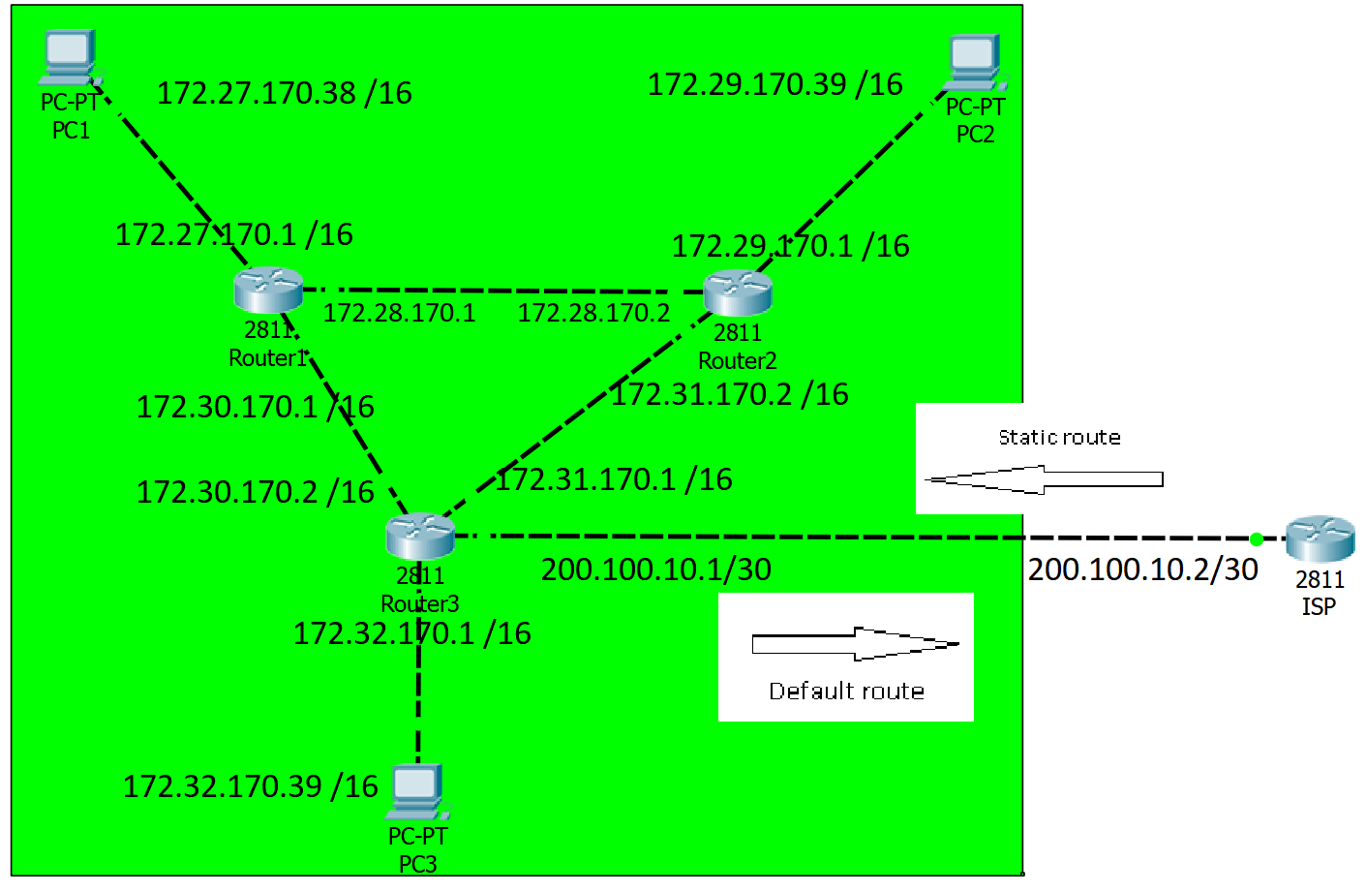

Step1: Assign static IPv4 addresses to router interfaces and computers

Router3(config)#interface fastethernet 0/0
Router3(config-if)#ip address 172.32.170.1 255.255.0.0
Router3(config-if)#no shutdown
Description: Add an IP address on Fa0/0subinterface
Steps for configuring RIP:

Router3(config)#router rip
Description: Enabling RIP routing protocol on the router

Router3(config-router)#version 2
Description: Specifying the RIP version to run

Router3(config-router)#network 172.30.0.0
Router3(config-router)#network 172.31.0.0
Router3(config-router)#network 172.32.0.0
Description: Configuring the network addresses to be included in routing updates

Router3(config-router)#no auto-summary
Description: disable auto summarization (if not, routes will be automatically summarized into classful network)

OBS: do not advertise network 200.100.10.0 using RIP

Optional: configure passive interfaces
RouterC(config)#router rip
Router3(config-router)#passive-interface Fa0/1
Description: stop RIP messages from being broadcasted out a specific interface

Steps for verifying RIP:

Router3 #show ip route
Description: Visualize the routing table

Router3 #show ip protocols
Description: routing status

Test the connectivity.

  - ping <target IP>
  - tracert <target IP>

Create static routes:
- default route:
On router R3 create a default route to network 200.100.10.0 /24 (static route)
- static route
On router ISP create a static route to the summarized network address
(requirement: summarize the following networks 172.27.170.0 - 172.33.170.0)

Propagate the default route to all the routers in the network,:

Router3(config)#ip route 0.0.0.0 0.0.0.0 200.100.10.2
Router3(config)#router rip
Router3(config-router)#default-information originate
Description: advertise a default route to other routers using RIP

RouterISP(config)#ip route 172.0.0.0 255.192.0.0 200.100.10.1

